HERO WEC LAMP Test Raw Data (TDMS Files)
Raw data from each LAMP test run of the HERO WEC can be found in the sorted TDMS files. TDMS files are a proprietary data format by NI and are the output measurement files from the HERO WEC MODAQ. Each folder contains files from one test run. Within each folder is a subfolder for each DAQ measurement group containing all TDMS files recorded by that DAQ measurement group during the test run. Due to file storage concerns, each measurement group saves a TDMS file every ten minutes, limiting the maximum file size. Raw data from these files can be viewed using a TDMS viewer software such as Scout or Microsoft Excel add-ins. To perform further analysis on the large volume of data collected, TDMS files are converted into Parquet files. The next section details the TDMS to Parquet conversion process.
Table 1: TDMS Subfolders.
Subfolder Name | DAQ
Anchor_LC | Anchor load cell
Buoy | On-buoy MODAQ
CurrentAI | Onshore current transducer sensors
PowRaw | Generator output (electric configuration only)
VoltageAI | Onshore voltage transducer sensors

HERO WEC LAMP Test Data (Parquet Files)
Processing used Python 3.10 and the nptdms library to read all TDMS files collected during testing and prepare them to be used for data analysis in MATLAB. Using Python, TDMS files collected by each DAQ measurement group during a single test case were first concatenated in chronological order then data from all DAQs was merged into a single data frame. Since the velocity and power calculations to be performed during data analysis require all data points to use a common time stamp, Python was then used to interpolate all data onto each data group’s time array and output one data frame per data group. Each data frame contains raw data for that group’s sensors and time array along with interpolated data for all other sensors at the selected data group’s time stamps. The Pecos quality control add-in was then used to identify and replace data points outside of each sensor’s measurement range and anomalous data points. These data points were replaced with interpolated data. In cases where the encoder crossed zero during a test, raw data showed a discontinuity at each zero-crossing event and an additional Python script was used to recalculate these arrays as degrees from initial encoder position as opposed to absolute encoder position. This array was named AIN_AIN2_ZERO_CROSS_FIX_DESPIKED. A description of each column contained in HERO WEC data Parquet files can be found in table 2 and sensor diagrams can be found in figures 1 through 4 in the MATLAB data section.
The output QC files, interpolated by group timestamp, present one complete test run in one file. In each file, relevant measurement columns are included, with the group column (indicated in the filename) representing the original timestamps. The additional columns are interpolated to provide data precisely at the group timestamp, enabling analysis of measurements across different groups. It is crucial to note that data outside of the original group is interpolated. Particularly in cases of faster sample rates, a significant volume of interpolated data from slower sample rate columns is present. For instance, consider a 5000 Hz PowRaw AIN_AIN1 column collected at 10 Hz, where approximately 500 samples of interpolated data exist between each actual data point. While this approach simplifies analysis across measurement groups, users are advised to exercise caution and apply it selectively, especially when dealing with substantial amounts of interpolated data resulting from higher sample rates.

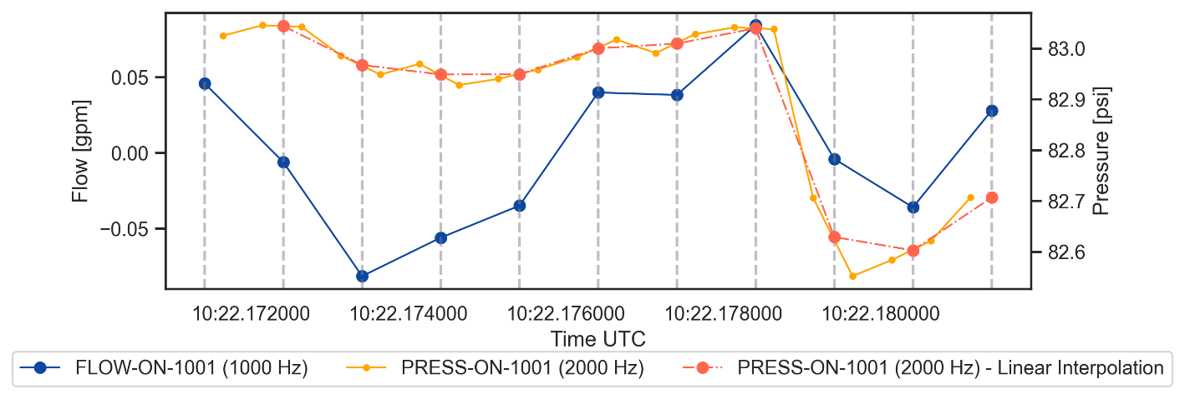
Figure 1 – PRESS-ON-1001 interpolated to timestamps of FLOW-ON-1001
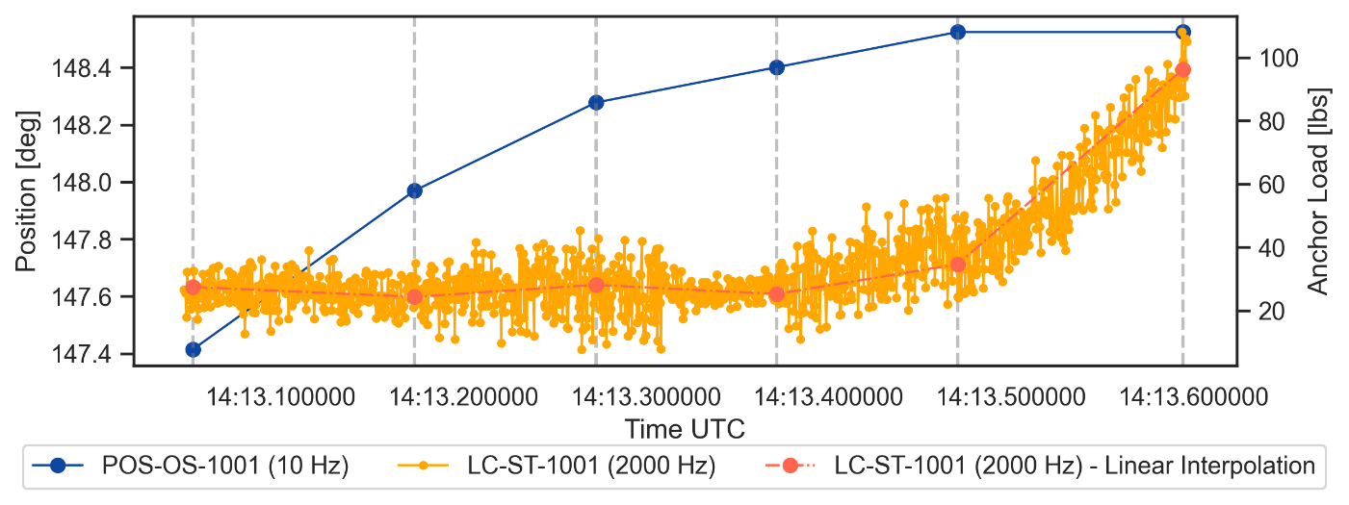
Figure 2 – Anchor Load (LC-ST-1001) interpolated to timestamps of WEC Winch Position (AIN-2)

Table 2: Parquet File Column Descriptions.
Column Name | Description | Units
Timestamp_NS | Selected DAQ timestamp | Nano-Seconds
Time_Elapsed_NS | Elapsed time | Nano-Seconds
IMF_orientation_x | IMF quaternion x orientation | Degrees
IMF_orientation_y | IMF quaternion y orientation | Degrees
IMF_orientation_z | IMF quaternion z orientation | Degrees
IMF_orientation_w | IMF quaternion w orientation | Degrees
IMF_angular_velocity_x | IMF angular velocity about x-axis | Degrees/second
IMF_angular_velocity_y | IMF angular velocity about y-axis | Degrees/second
IMF_angular_velocity_z | IMF angular velocity about z-axis | Degrees/second
IMF_linear_acceleration_x | IMF x acceleration | m/s^2
IMF_linear_acceleration_y | IMF y acceleration | m/s^2
IMF_linear_acceleration_z | IMF z acceleration | m/s^2
AIN_AIN0 | Unscaled WEC air tank pressure (PRESS_OS_2002) | mA
AIN_AIN1 | Unscaled hydraulic pump pressure (PRESS_OS_1001) | mA
AIN_AIN2 | Unscaled encoder position (POS_OS_1001) | mA
AIN_AIN3 | Unscaled hydraulic pump flow rate (FLOW_OS_1001) | mA
AIN_AIN2_ZERO_CROSS_FIX_DESPIKED | Encoder position (POS_OS_1001) in degrees from initial position ranging from -360 to 360. Only used when the encoder crossed zero during testing. | Degrees
IMU_orientation_x | IMU Quaternion x orientation | Degrees
IMU_orientation_y | IMU Quaternion y orientation | Degrees
IMU_orientation_z | IMU Quaternion z orientation | Degrees
IMU_orientation_w | IMU Quaternion w orientation | Degrees
IMU_angular_velocity_x | IMU angular velocity about x-axis | Degrees/second
IMU_angular_velocity_y | IMU angular velocity about y-axis | Degrees/second
IMU_angular_velocity_z | IMU angular velocity about z-axis | Degrees/second
IMU_linear_acceleration_x | IMU x acceleration | m/s^2
IMU_linear_acceleration_y | IMU y acceleration | m/s^2
IMU_linear_acceleration_z | IMU z acceleration | m/s^2
MAG_magnetic_field_x | Magnetic flux in x-direction | Gauss
MAG_Magnetic_field_y | Magnetic flux in y-direction | Gauss
MAG_Magnetic_field_z | Magnetic flux in z-direction | Gauss
HDG_Heading | WEC heading relative to true North | degrees
PowRaw_PT_ON_1001 | Generator phase 1 voltage | Volts
PowRaw_PT_ON_1002 | Generator phase 2 voltage | Volts
PowRaw_PT_ON_1003 | Generator phase 3 voltage | Volts
PowRaw_CT_ON_1001 | Generator phase 1 current | Amps
PowRaw_CT_ON_1002 | Generator phase 2 current (not used) | Amps
PowRaw_CT_ON_1003 | Generator phase 3 current (not used) | Amps
VoltageAI_PT_ON_2001 | Post-rectifier voltage | Volts
VoltageAI_PT_ON_2002 | Charge controller input voltage | Volts
VoltageAI_PT_ON_2003 | Charge controller output voltage | Volts
VoltageAI_PT_ON_2004 | Battery voltage | Volts
VoltageAI_PT_ON_2005 | Pump controller input voltage | Volts
VoltageAI_PT_ON_2006 | Pump 1 voltage | Volts
VoltageAI_PT_ON_2007 | Pump 2 voltage | Volts
VoltageAI_CT_ON_2001 | Post-rectifier current | Amps
VoltageAI_CT_ON_2002 | Charge controller input current | Amps
VoltageAI_CT_ON_2003 | Charge controller output current | Amps
VoltageAI_CT_ON_2004 | Battery current | Amps
VoltageAI_CT_ON_2005 | Pump controller input current | Amps
VoltageAI_CT_ON_2006 | Pump 1 current | Amps
VoltageAI_CT_ON_2007 | Pump 2 current | Amps
VoltageAI_PRESS_ON_1001 | RO inlet pressure | psi
VoltageAI_PRESS_ON_1002 | RO post-accumulator pressure | psi
VoltageAI_PRESS_ON_1003 | Clark pump inlet pressure | psi
VoltageAI_LVL_ON_1001 | Permeate level (not used) | cm
CurrentAI_FLOW_ON_1001 | RO inlet flow rate | Gpm
CurrentAI_FLOW_ON_1002 | RO post accumulator flow rate | Gpm
CurrentAI_FLOW_ON_1003 | Brine discharge flow rate | Gpm
CurrentAI_FLOW_ON_1004 | Permeate flow rate | Gpm
CurrentAI_CND_ON_1001 | Sea water conductivity | microSiemens
CurrentAI_CND_ON_1002 | Permeate conductivity | microSiemens
CurrentAI_POS_OS_1001 | Encoder position (when saved to onshore DAQ) | Degrees
CurrentAI_FLOW_OS_1001 | Hydraulic pump flow rate | Gpm
Anchor_LC_LC_ST_1001 | Winch line tension | lbf

HERO WEC LAMP Test Data (MATLAB)
Each HERO WEC data workspace is produced using the Parquet files output by the data processing Python script using the TDMS files for an individual test case. A complete list of test cases with file names, wave case information, and notes can be found in the HERO WEC LAMP Test Run Log spreadsheet. Parquet files from each test were processed using MATLAB to output a saved workspace to be used for data analysis. For each configuration of the HERO WEC, a different Parquet file was used to ensure that raw data from the most relevant sensors to each test was used for data analysis. For hydraulic and drivetrain tests, interpolation by AIN (10 Hz) data was used to produce workspaces. For electric tests, interpolation by PowRaw (5000 Hz) data was used to produce workspaces. Each data workspace includes data from each sensor used during the test case, a time array, and calculated values used to analyze component and system performance. Names of all variables which are calculated from test data begin with “Calc_”. Due to low sample rates on the on buoy DAQ, some data needed to be smoothed before certain calculations could be performed. This was performed using MATLAB’s smoothdata function and names of all arrays of smoothed data end with “_S”. Issues with the anchor load cell prevented winch line tension data from being saved in all cases. In these cases, a Simulink model which was calibrated from the experimental data was used to calculate a winch line tension array based on the encoder data recoded during the test, this array is named “Sim_LC_ST_1001”.
Table 3: MATLAB Array Descriptions.
Array Name | Description | Subsystem | Units
Time | DAQ time array starting at zero | MODAQ | Seconds
PRESS_OS_1001 | Hydraulic pump outlet pressure | WEC (Hydraulic) | psi
PRESS_OS_2002 | WEC air tank pressure | WEC | psi
POS_OS_1001 | Low speed spring return shaft position | WEC | Degrees
FLOW_OS_1001 | Hydraulic pump outlet flow rate | WEC (Hydraulic) | Gpm
PRESS_ON_1001 | RO system inlet pressure | RO | psi
PRESS_ON_1002 | Clark pump inlet pressure | RO | psi
FLOW_ON_1001 | RO inlet flow rate | RO | Gpm
FLOW_ON_1002 | Clark pump inlet flow rate | RO | Gpm
FLOW_ON_1003 | Brine discharge flow rate | RO | Gpm
FLOW_ON_1004 | Permeate flow rate | RO | Gpm
CND_ON_1001 | RO inlet water conductivity | RO | microSiemens
CND_ON_1002 | Permeate conductivity | RO | microSiemens
LC_ST_1001 | Anchor load cell | Anchor | Pound force
PT_ON_1001 | Generator phase 1 voltage | WEC (Electric) | Volts
PT_ON_1002 | Generator phase 2 voltage | WEC (Electric) | Volts
PT_ON_1003 | Generator phase 3 voltage | WEC (Electric) | Volts
CT_ON_1001 | Generator phase 1 current | WEC (Electric) | Amps
PT_ON_2001 | Post rectifier voltage | Power electronics | Volts
CT_ON_2001 | Post rectifier current | Power electronics | Amps
PT_ON_2002 | Charge controller input voltage | Power electronics | Volts
CT_ON_2002 | Charge controller input current | Power electronics | Amps
PT_ON_2003 | Charge controller output voltage | Power electronics | Volts
CT_ON_2003 | Charge controller output current | Power electronics | Amps
PT_ON_2004 | Battery voltage | Power electronics | Volts
CT_ON_2004 | Battery current | Power electronics | Amps
PT_ON_2005 | Pump controller input voltage | Power electronics | Volts
CT_ON_2005 | Pump controller input current | Power electronics | Amps
PT_ON_2006 | Pump 1 voltage | Power electronics | Volts
CT_ON_2006 | Pump 1 current | Power electronics | Amps
PT_ON_2007 | Pump 2 voltage | Power electronics | Volts
CT_ON_2007 | Pump 2 current | Power electronics | Amps

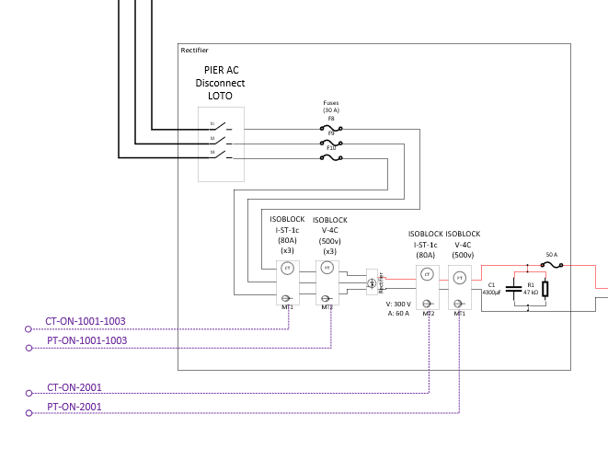
Figure 1: Location of PT and CT sensors used to measure 3 phase AC electricity from generator and DC electricity after rectifier.
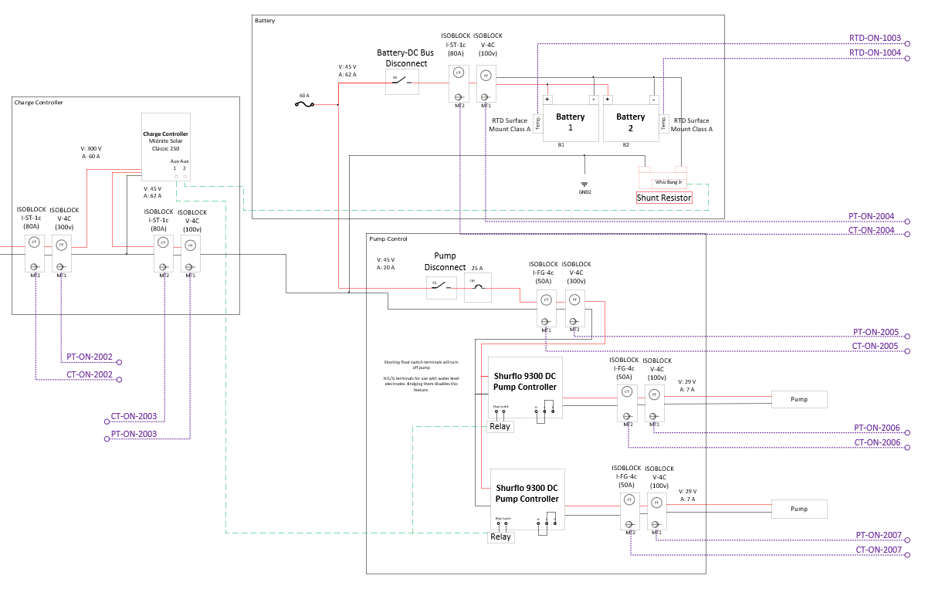
Figure 2: Location of PT and CT sensors after rectifier.
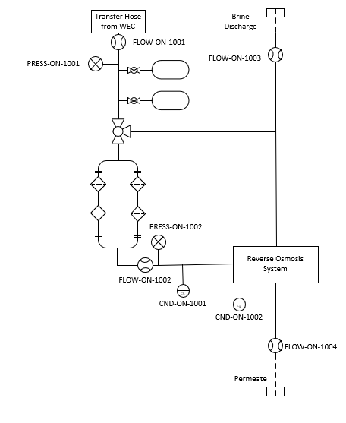
Figure 3: Location of RO system sensors.

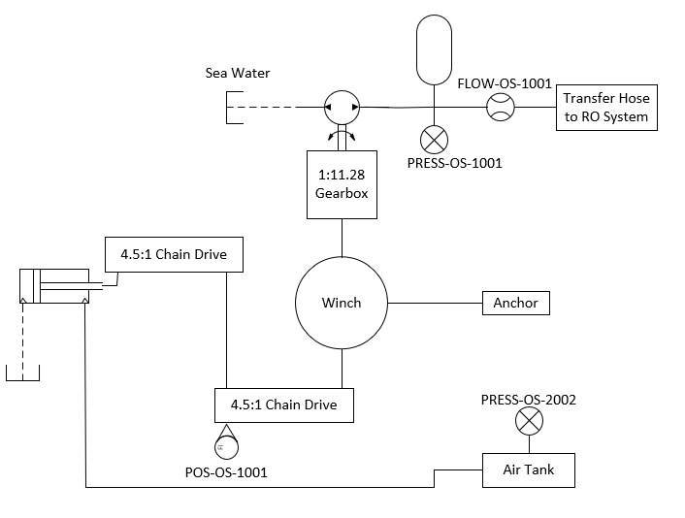
Figure 4: Location of on-WEC sensors.
MATLAB was used to calculate additional data useful for analysis of the HERO WEC’s performance during testing. Encoder velocity was calculated using the forward difference method on smoothed encoder data. Winch and gearbox data was then calculated using the known gear ratios of the spring return chain drive and the gearbox. The absorbed power of the WEC was calculated using the winch velocity and winch line tension. Hydraulic power calculations were performed using the flow rate and pressure at each measured point in the system. DC electric power was calculated using the current and voltage at each measured point in the system. AC average power calculations were performed by integrating the instantaneous DC power of a single phase of the generator over the duration of the test to find total electrical work, dividing by the length of the test to find average power output of the single phase, then multiplying by 3 under the assumption that all three phases of the generator produce identical power during testing. Average power during each test was then used to calculate efficiencies and losses across various components and subsystems. Trapezoidal integration was used to calculate total volume of water moved through the system at various points over the duration of the test.
Table 4: MATLAB Calculated and Simulated Arrays.
Name | Description | Units
POS_OS_1001_S | Smoothed encoder data used for winch velocity calculation | Degrees
Calc_POS_Winch | Winch position. Encoder data multiplied by first stage of spring return ratio (4.5:1) and offset by first data point in POS_OS_1001_S array. | Degrees
Diff_Time | Time array used to calculate velocity and power arrays (shortened by 1 data point to reflect forward difference method used to calculate velocity)  Length(Diff_Time) = Length(Time) - 1 | Seconds
Calc_V_Encoder | Encoder velocity calculated using forward difference method (see Diff_Time) | rpm
Calc_V_Winch | Winch velocity. Calc_V_Encoder multiplied by 4.5 (first stage spring return ratio) | rpm
Calc_V_Gearbox | Gearbox output shaft velocity. Calc_V_Winch multiplied by 11.28 (gearbox ratio) | rpm
Calc_P_abs | Instantaneous absorbed power (Calc_V_Winch * LC_ST_1001) | kW
Calc_P_WEC_Electric_Out | Instantaneous power output from generator | kW
Calc_Eta_WEC_Electric | Drivetrain efficiency during test (winch to generator) | %
Calc_P_Electric_1 | Instantaneous post-rectifier electric power | kW
Calc_Eta_Rectifier_Instantaneous | Instantaneous rectifier efficiency | %
Calc_P_Electric_2 | Instantaneous charge controller input power | kW
Calc_P_Electric_3 | Instantaneous charge controller output power | kW
Calc_Eta_CC_Instantaneous | Instantaneous charge controller efficiency | %
Calc_P_Electric_4 | Instantaneous power into batteries | kW
Calc_P_Electric_5 | Instantaneous power supplied to pump controllers | kW
Calc_P_Electric_P1 | Instantaneous power supplied to pump 1 | kW
Calc_P_Electric_P2 | Instantaneous power supplied to pump 2 | kW
Calc_Filter_DP | Pressure differential across RO pre-filter | psi
Calc_ACC_Flow | Flow rate into onshore accumulators | Gpm
Calc_P_Hydraulic_1 | Hydraulic power at pump outlet | kW
Calc_P_Hydraulic_2 | Hydraulic power at RO system inlet | kW
Calc_P_Hydraulic_3 | Hydraulic power at Clark pump inlet | kW
Calc_Recovery_Ratio | RO recovery ratio during test | -
Sim_LC_ST_1001 | Instantaneous winch line tension calculated using Simulink. Only used in test cases where anchor load cell data was not recorded. | Pound force

Table 5: MATLAB Calculated and Simulated Values
Calc_Tension_AVG | Average load cell output (i.e. tension) during test | Pound force
Calc_Tension_Max | Maximum load cell output during test | Pound force
Start.Index | Index of first data point in LAMP test profile where motion initiates | -
Start.Time | Time value of Start.Index | Seconds
End.Index | Index of last data point in LAMP test profile (end of hold period) | -
End.Time | Time value of End.Index | Seconds
Calc_P_abs_AVG | Average absorbed power during test | kW
Calc_Q_Pump_AVG | Average flow rate supplied by hydraulic pump during test | Gpm
Calc_P_WEC_Electric_Out_AVG | Average power output of generator during test | kW
Calc_P_Electric_1_AVG | Average post-rectifier electric power during test | kW
Calc_Eta_Rectifier | Rectifier efficiency during test | %
Calc_P_Electric_2_AVG | Average charge controller input power during test | kW
Calc_P_Electric_3_AVG | Average charge controller output power during test | kW
Calc_Eta_CC | Charge controller efficiency during test | %
Calc_Eta_Electric_Overall | Overall electrical system efficiency during test (winch to charge controller output) | %
Calc_P_Electric_4_AVG | Average power into batteries during test | kW
Calc_Battery_Charge | Calculated energy input to battery over duration of test (positive value indicates battery charge, negative value indicates battery discharge) | kWh
Calc_P_Electric_5_AVG | Average power supplied to pump controllers during test | kW
Calc_P_Electric_P1_AVG | Average power supplied to pump 1 during test | kW
Calc_P_Electric_P2_AVG | Average power supplied to pump 2 during test | kW
Calc_Loss_Conversion | Conversion loss at electric pumps | -
Calc_Q_Feed_AVG | Average flow rate into RO system during test | Gpm
Calc_Volume_Pump | Total volume of water moved by hydraulic pump during test (in the electric configuration with RO on, this is equivalent to Calc_Volume_RO) | Gallons
Calc_Volume_RO | Total volume of water received at RO | Gallons
Calc_Volume_PRV | Total volume of water discharged by pressure relief valves during test. Calc_Volume_Pump – Calc_Volume_RO | Gallons
Calc_Volume_Permeate | Total volume of fresh water produced during test | Gallons
Calc_PRV_Percent | Percent of water pumped that is discharged by pressure relief valves during test | %
Calc_P_Hydraulic_1_AVG | Average hydraulic power at pump outlet during test | kW
Calc_P_Hydraulic_2_AVG | Average hydraulic power at RO system inlet during test | kW
Calc_P_Hydraulic_3_AVG | Average hydraulic power at Clark pump inlet during test | kW
Calc_Loss_Filter | Percent of energy loss across RO pre-filter | %
Calc_Eta_Overall | Overall system efficiency during test (winch to Clark pump) | %
Calc_Q_Permeate_AVG | Average permeate flow rate during test | Gpm
Calc_Loss_Transfer | Percent of energy loss across hydraulic transfer hose | %
Sim_Tension_AVG | Average winch line tension calculated using Simulink | Pound force
Sim_Tension_Max | Maximum winch line tension calculated using Simulink | Pound force
Run.Time | End.Time – Start.Time | Seconds
Calc_Eta_WEC_Hydraulic | Drivetrain efficiency in hydraulic configuration during test (winch to pump or output) | %
Calc_Eta_WEC_Electric | Drivetrain efficiency in electric configuration during test (winch to generator output) | %

